Name: Akhilesh Munishwar
PRN.: 1262242269
Roll no.: 28
Panel: G

School of Computer Science and Engineering
Department of Computer Engineering and Technology
T. Y. B. Tech CSE
AY 2026-27 Semester V
Computer Networks Lab (CSE20110)
Assignment No.: 1
Title: Design a simple network (LAN) with different topologies & test it using PING utility
Objective:
- To learn and understand the concept of LAN and test it using the PING command.
- To design a network using various network topologies in Cisco Packet Tracer.
Theory:
Students have to write a theory covering the following points.
- Brief description of various Network Topologies
- Advantages and Disadvantages of each topology.

Network Topologies
A network topology refers to the physical or logical arrangement of nodes (computers, switches, routers, etc.) and the links connecting them in a network. The choice of topology directly affects the cost of installation, the ease of troubleshooting, the fault tolerance of the network, and how well the network scales as more devices are added. Below is a brief description of the five topologies covered in this assignment.
Bus Topology
In a bus topology, all the devices are connected to a single central cable, often called the backbone or trunk. Every device taps directly into this shared cable, and data sent by any device travels along the bus until it reaches its destination. Because only one device can transmit at a time without collisions, bus networks tend to slow down as more devices are added, and a break anywhere in the backbone cable can bring down communication for the entire segment.
Star Topology
In a star topology, every device is connected individually to a central node, which is usually a hub or a switch. All the data traffic in the network passes through this central device. This design makes it very easy to add, remove, or troubleshoot individual devices without disturbing the rest of the network, since a cable fault only affects the single device connected to it. The main drawback is that the whole network depends on the central hub or switch — if it fails, every connected device loses network access.
Ring Topology
In a ring topology, each device is connected to exactly two other devices, forming a closed loop or ring. Data travels around the ring in one direction (or sometimes both, in a dual-ring setup), passing through each intermediate device until it reaches its destination. This arrangement avoids the collisions that occur in a bus topology, but a failure in any single link or device can disrupt communication across the whole ring unless a backup path is available.
Mesh Topology
In a mesh topology, devices are interconnected with multiple redundant paths between them. In a full mesh, every device has a direct link to every other device, which makes the network extremely fault-tolerant since traffic can be rerouted if one link goes down. The obvious trade-off is cost and complexity — the amount of cabling and the number of interfaces required grows very quickly as more devices are added, which makes full mesh impractical for large networks.
Tree Topology
A tree topology is essentially a hierarchical combination of star networks, where groups of star-configured devices are connected to a central bus or backbone. It is commonly used in larger organizations where different departments or floors need their own local star network, all of which are then linked together through a common backbone. It combines the manageability of star topology with the scalability of a bus-like backbone, though the backbone itself becomes a single point of failure for the branches connected to it.

Comparison of Topologies
The table below summarizes the key advantages and disadvantages of each topology discussed above.
Topology | Advantages | Disadvantages
Bus | Simple and cheap to set up; uses less cable than other layouts. | One break in the backbone cable can take the whole network down; performance drops as more devices are added.
Star | If one cable or node fails, the rest of the network keeps working; easy to add or remove a device; simple to troubleshoot. | Entire network depends on the central hub/switch; more cabling is needed compared to bus.
Ring | Data flows in a predictable, orderly manner; performs reasonably well under heavy load compared to bus. | A single broken link can disrupt the whole ring (unless it's dual-ring); adding or removing a node disturbs the network.
Mesh | Highly reliable and fault-tolerant since multiple paths exist between nodes; failure of one link doesn't isolate a device. | Very expensive and complex to wire, especially a full mesh; difficult to manage and scale.
Tree | Combines the benefits of star and bus; easy to extend and manage in a hierarchical, department-wise fashion. | If the root/backbone fails, the connected branches lose contact with each other; more cabling and planning required.

Steps of Execution:
- Open Cisco Packet Tracer and create a new blank workspace.
- Place the required number of end devices (PCs) and the appropriate connecting device (hub/switch)
- based on the topology being designed.
- Connect the devices using the correct cable type (straight-through/cross-over as needed) to form the desired topology — Bus, Star, Ring, Mesh, or Tree.
- Assign valid static IP addresses and subnet masks to every PC from the Desktop → IP Configuration window, keeping all devices in the same subnet.
- Move to the Command Prompt on a source PC and use the PING command (for example, ping 192.168.1.2) to test connectivity with other devices in the network.
- Observe the reply messages (or timeout/failure messages) to confirm whether the topology is working as expected, and capture screenshots of both the design and the successful PING output.
- Repeat the above steps for each of the five topologies — Ring, Mesh, Bus, Star, and Tree.
Design Screenshots:
Paste design screenshots, ping command for various topologies. (Paste for Ring, Mesh, Bus, Star, Tree)
- Bus Topology
- Star Topology
- Ring Topology
- Mesh Topology

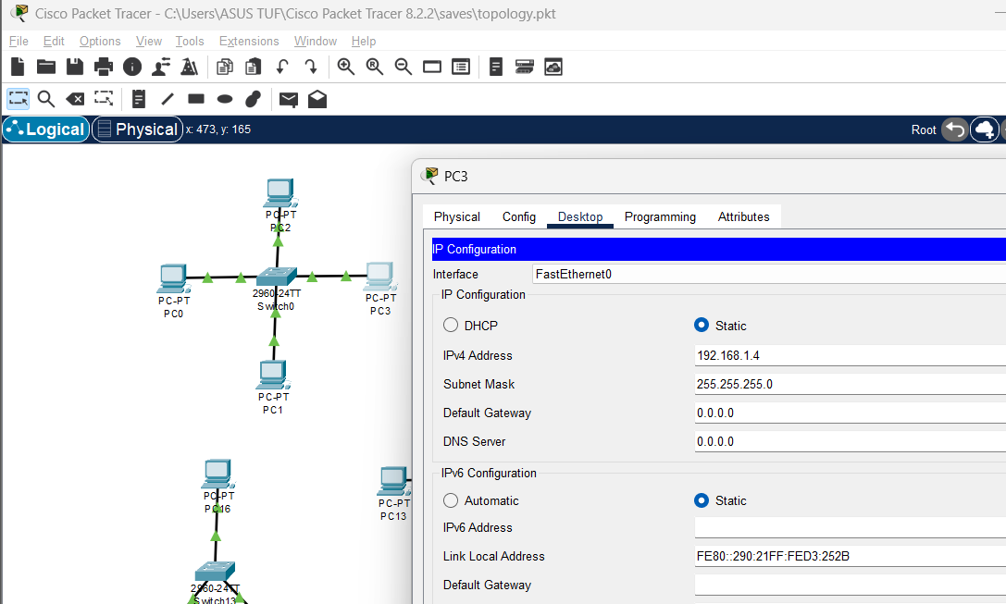

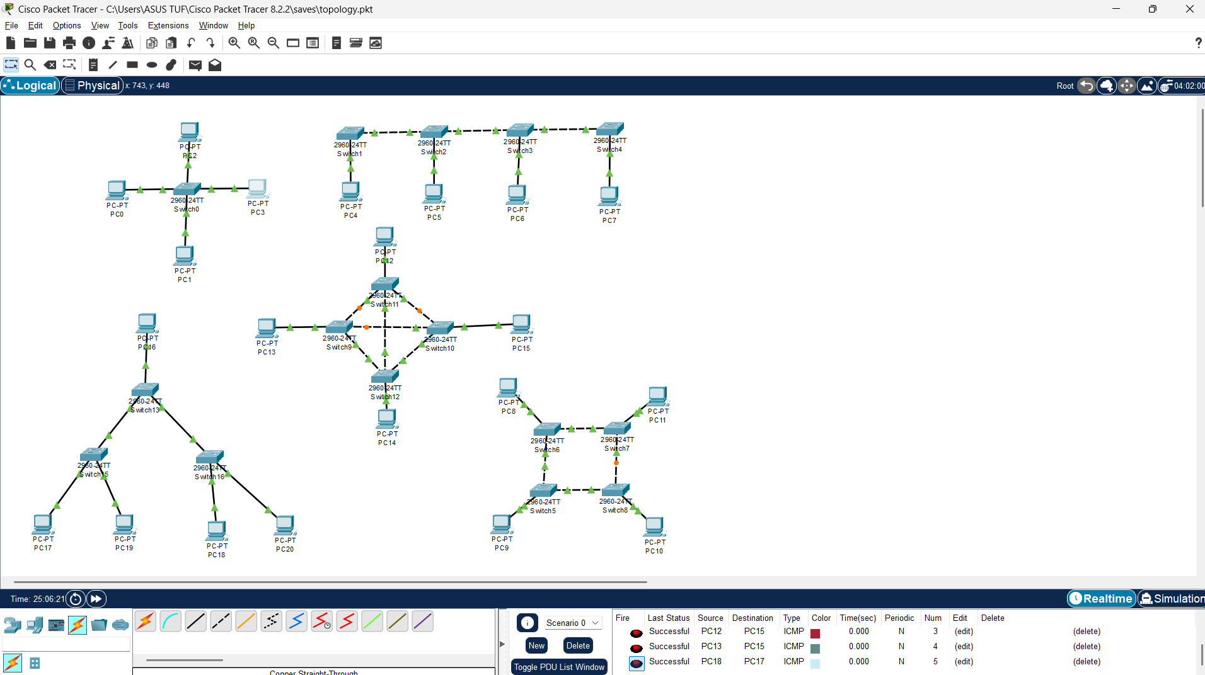

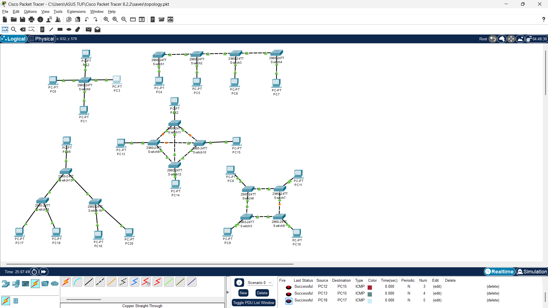

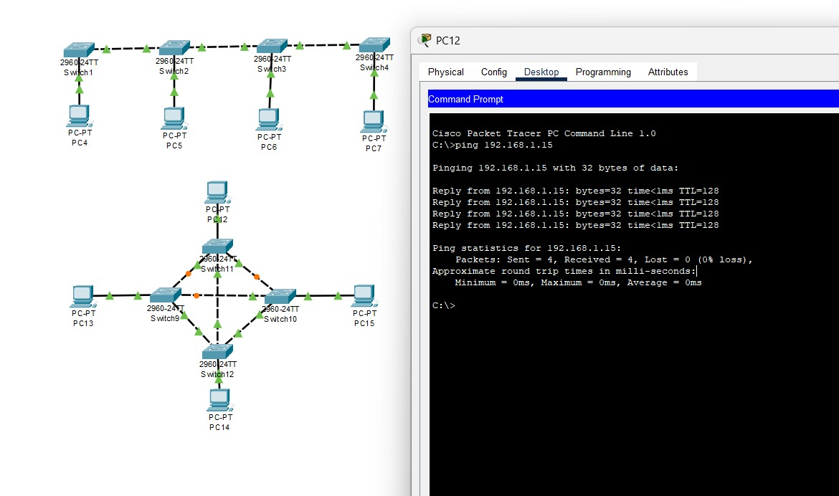

Conclusion:
Through this experiment, we were able to design and simulate five different LAN topologies — Bus, Star, Ring, Mesh, and Tree — using Cisco Packet Tracer, and verify connectivity between the devices in each topology using the PING utility. Successful PING replies confirmed that the devices were correctly configured and reachable within the same network, while the differences in cabling and device arrangement across topologies helped in understanding the practical trade-offs between cost, fault tolerance, and scalability discussed in the theory. Overall, the lab gave a hands-on understanding of how the underlying physical layout of a network influences its reliability and performance.

FAQ:
Students to write and upload scanned document.
1. Define in detail LAN with diagrams.
A Local Area Network (LAN) is a network that connects computers and other devices within a limited geographical area such as a home, office, lab, or a single building. LANs are characterized by high data transfer rates, low latency, and ownership by a single organization, which makes centralized management and security relatively straightforward. A typical LAN consists of end devices (PCs, printers, servers) connected through switches or hubs, often with a router providing access to external networks such as the internet.
2. Explain PING utility.
PING (Packet Internet Groper) is a network diagnostic utility used to test whether a particular host is reachable over an IP network and to measure the round-trip time for messages sent from the source to the destination. It works by sending ICMP (Internet Control Message Protocol) Echo Request packets to the target device; if the device is reachable, it responds with ICMP Echo Reply packets. The output of the ping command typically shows the number of packets sent, received, and lost, along with the minimum, maximum, and average round-trip time.
3. What is the default subnet mask for all the classes of IP?
IPv4 addresses are divided into five classes (A through E), and each of the first three classes has a default subnet mask associated with it, as shown below.
Class | Default Subnet Mask | Address Range (1st octet)
Class A | 255.0.0.0 | 1 – 126
Class B | 255.255.0.0 | 128 – 191
Class C | 255.255.255.0 | 192 – 223
Class D (Multicast) | Not applicable | 224 – 239
Class E (Experimental) | Not applicable | 240 – 255

4. Compare all Topologies.
A detailed comparison of Bus, Star, Ring, Mesh, and Tree topologies, including their advantages and disadvantages, has been provided in the Theory section above under "Comparison of Topologies." In general, Bus is the cheapest but least fault-tolerant; Star is the easiest to manage and troubleshoot but depends entirely on the central device
5. What is Hub and Switch?
A hub and a switch are both devices used to connect multiple computers within a LAN, but they work very differently. A hub is a simple, passive device that operates at the Physical Layer of the OSI model — whenever it receives data on one port, it broadcasts that data out to every other connected port, regardless of the intended recipient. This leads to unnecessary traffic and a higher chance of data collisions as more devices are added. A switch, on the other hand, is an intelligent, active device that operates at the Data Link Layer. It learns the MAC addresses of connected devices and forwards data only to the specific port where the destination device is connected, which makes the network faster, more efficient, and better suited to handling heavier traffic.

